INSTALIRANJE PODMANA: sudo dnf install podman -y
VERZIJA PODMANA: podman –version
IZLAZ IZ BAZE: \q
OBRISATI STARI DB CONTAINER: podman stop db, podman rm db, podman network rm devnet
Spremi datoteku
- Ctrl + O (Write Out)
- Enter
- Ctrl + X (Exit)
Create a pod with podman pod create (publishing a port), add an app container and a database container to it, and show they reach each other over localhost (shared network namespace).
1.KORAK NAPRAVIMO POD I PUBLISHAMO PORT
Podman pod create –name devpod -p 8080:8080
- KORAK DODAMO DATABASE CONTAINER U POD
podman run -d --pod devpod --name db -e POSTGRES_USER=student -e POSTGRES_PASSWORD=student -e POSTGRES_DB=testdb docker.io/library/postgres:15
- KORAK DODAMO APP CONTAINER U ISTI POD
podman run -it --rm --pod devpod --name app docker.io/library/alpine sh
U TOM CONTAINERU INSTALIRAMO POSTGRE SQL
apk add --no-cache postgresql-client
- KORAK IZ TOG CONTAINERA SE SPOJIMO NA BAZU PREKO LOCALHOST
psql -h localhost -U student -d testdb
NAKON TOG TRAZI PASSWORD prm student
ONDA NAPRAVIMO NEKU TABLICU I UNESEMO PODATKE CISTO PRIMJER
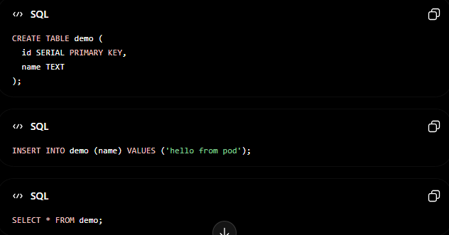

Create a user-defined network, run an app container and a postgres container on it, and prove the app resolves the database by container name (podman DNS on custom networks).
- KORAK NAPRAVI CUSTOM NETWORK
podman network create devnet
- KORAK POKRENI POSTGRES CONTAINER NA TOJ MREZI
podman run -d --name db --network devnet -e POSTGRES_USER=student -e POSTGRES_PASSWORD=student -e POSTGRES_DB=testdb docker.io/library/postgres:15
- KORAK POKRENI APP CONTAINER NA ISTOJ MREZI
podman run -it --rm --name app --network devnet docker.io/library/alpine sh
NAKON TOG INSTALIRATI POSTGRESS CLIENT
apk add --no-cache postgresql-client
- KORAK SPOJI SE NA BAZU PREKO IMENA CONTAINERA
psql -h db -U student -d testdb
Deploy a two-tier stack of your choice that is not Drupal/Joomla/WordPress (e.g. Ghost + MySQL, Gitea + PostgreSQL, or Redmine + PostgreSQL) and complete its first-run setup.
Prvo ocitimo stare kontenjere podman stop db app 2>/dev/null podman rm db app 2>/dev/null
- NAPRAVI MREŽU
podman network create gitea-net
- POKRENI POSTGRESQL DATABASE KONTENJER
podman run -d --name gitea-db --network gitea-net -e POSTGRES_USER=gitea -e POSTGRES_PASSWORD=gitea -e POSTGRES_DB=gitea docker.io/library/postgres:15
- POKRENI GITEA APP CONTAINER
podman run -d --name gitea --network gitea-net -p 3000:3000 -p 2222:22 -e GITEA__database__DB_TYPE=postgres -e GITEA__database__HOST=gitea-db:5432 -e GITEA__database__NAME=gitea -e GITEA__database__USER=gitea -e GITEA__database__PASSWD=gitea docker.io/gitea/gitea:latest
- OTVORI GITEA U BROWSERU
http://localhost:3000
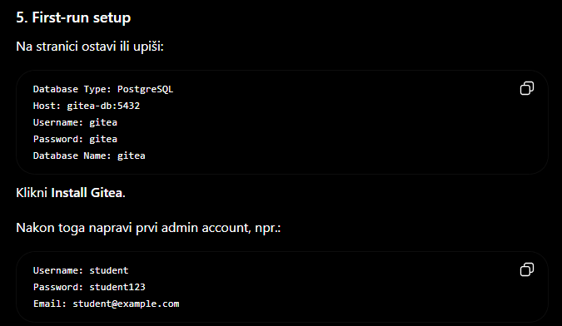
Persist the database's data in a named volume so it survives podman rm + re-creation of the DB container; prove the data is still there afterward
- NAPRAVIMO NAMED VOLUME
podman volume create pgdata
- POKRENI POSTGRESQL S VOLUMEOM
podman run -d --name db -e POSTGRES_USER=student -e POSTGRES_PASSWORD=student -e POSTGRES_DB=testdb -v pgdata:/var/lib/postgresql/data docker.io/library/postgres:15
- UĐEMO U BAZU I NAPRAVIMO PODATKE
podman exec -it db psql -U student -d testdb
- OBRISI DB CONTAINER
- PONOVNO KREIRAJ DB CONTAINER S ISTIM VOLUMENOM
podman run -d --name db -e POSTGRES_USER=student -e POSTGRES_PASSWORD=student -e POSTGRES_DB=testdb -v pgdata:/var/lib/postgresql/data docker.io/library/postgres:15
- DOKAZI DA SU PODACI OSTALI
podman exec -it db psql -U student -d testdb
Use a podman secret (podman secret create + --secret) to pass the database password instead of --env; explain the security benefit.
- KREIRAJ SECRET
echo "student123" > dbpass.txt
KREIRAJ PODMAN SECRET
podman secret create pgpassword dbpass.txt
- POKRENI POSTGRESQL KORISTECI SECRET
podman run -d --name db --secret pgpassword -e POSTGRES_USER=student -e POSTGRES_DB=testdb -e POSTGRES_PASSWORD_FILE=/run/secrets/pgpassword docker.io/library/postgres:15
- PROVJERI DA SECRET POSTOJI
podman exec -it db bash
cat /run/secrets/pgpassword
Write a podman compose file (compose.yaml) for an app + database, bring it up with podman compose up d, and show both services running.
KREIRANJE DIREKTORIJA mkdir compose-demo I cd compose-demo
- NAPRAVIMO DATOTEKU nano compose.yaml
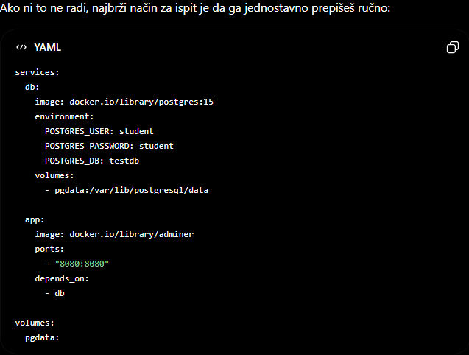
cat compose.yaml
podman compose up -d
podman ps
podman compose down

In that compose file, keep the database on an internal network with no published port and expose only the app; prove the DB isn't reachable from the host.
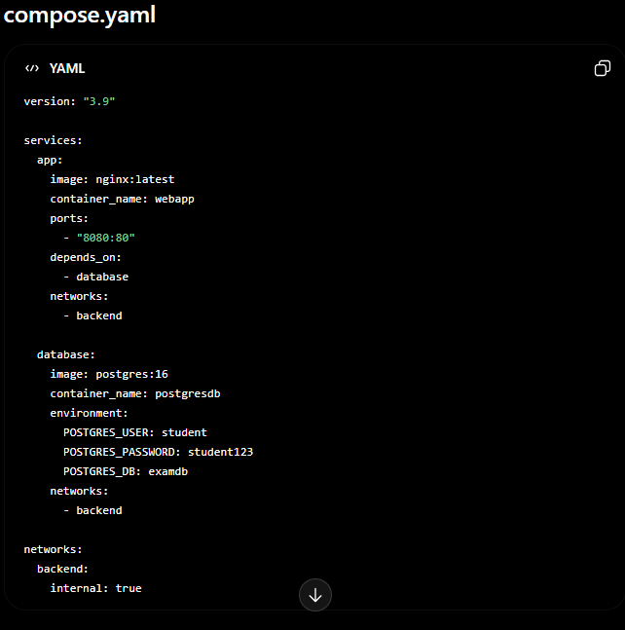
Podman compose up -d
Podman ps
curl http://localhost:8080
psql -h localhost -U student -d examdb (provjera da nije dostupno od hosta)

Add a compose healthcheck plus depends_on: condition: service_healthy so the app waits for the database; demonstrate the startup ordering.
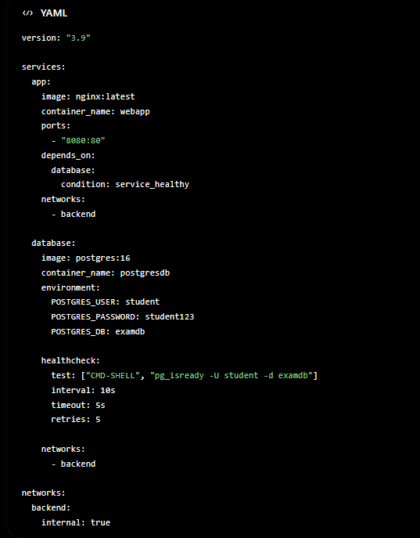
podman compose up -d
podman ps
podman compose logs

Use an env_file: in compose for the database credentials instead of inline values.
nano .env
POSTGRES_USER=student
POSTGRES_PASSWORD=student123
POSTGRES_DB=examdb
Ažuriraj env file:
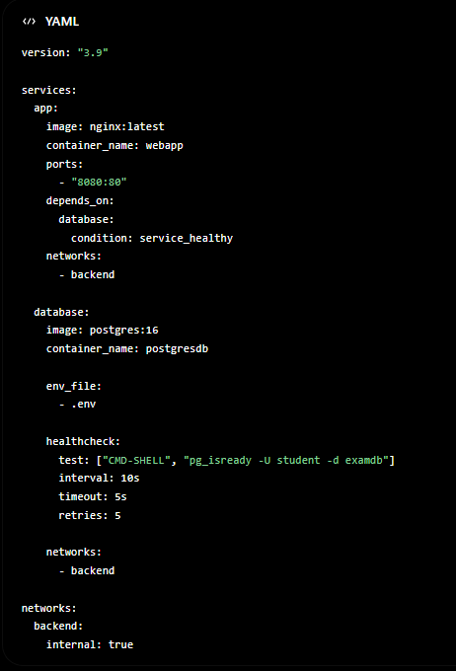
Podman compose up-d
Podman ps

Scale one compose service to multiple replicas (podman compose up --scale app=3) and explain how requests are distributed.
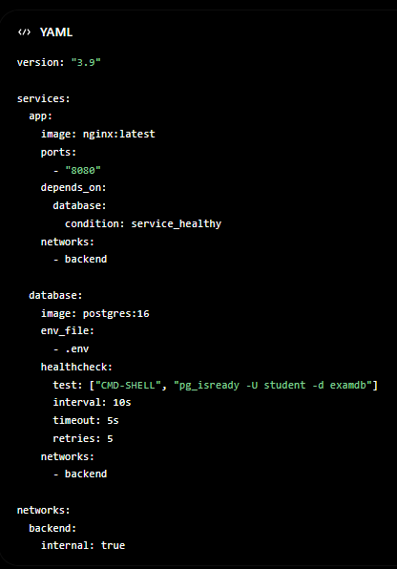
Podman compose up -d –-scale app=3
Podman ps

Mount a bind mount for app configuration and a named volume for data in the same container, and explain why you'd use each.
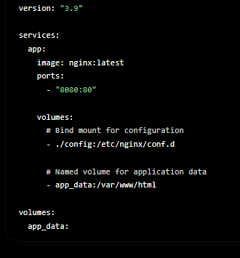
Bind mount- it easy to edit configuration files on the ost. He changes appear immediately inside the container and its good for development or configuration files.
Named volume: He stores presistent application data and data remains even if the container is removed. He is managed automatically by podman and better for databases and application data.
Podman compose up -d
Podman inspect app or podman volume ls
Back up a named volume to a tarball using a helper alpine/busybox container that mounts the volume, then restore it into a fresh volume.
Prvo back up named volume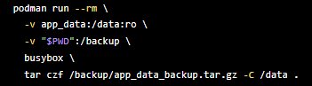
Druge create fresh volume podman volume create app_data_restored
Trece restore tarball into fresh volume 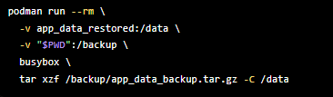
Cetvrto verify restored data 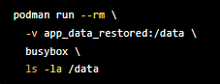
Put an nginx reverse-proxy container in front of an app container on a shared network and route host traffic through nginx to the app.
nano nginx.conf
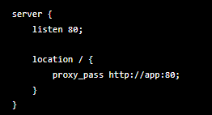
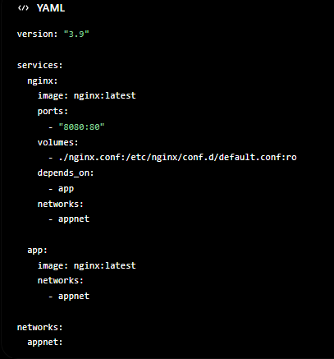

Add a database-admin container (e.g. adminer or pgadmin) to the network and use it to inspect the database.
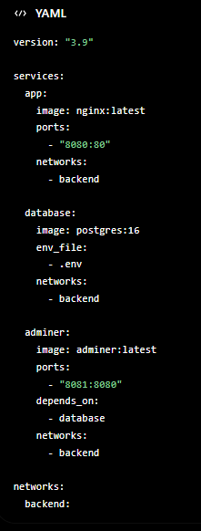
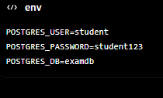
podman compose up -d
podman ps
http://localhost:8081
Login with:
- System: PostgreSQL
- Server: database
- Username: student
- Password: student123
- Database: examdb
Generate Kubernetes YAML from a running pod with podman generate kube and explain how it bridges LO3 to LO4.
Prvo run a pod/container first: podman run -d --name myapp -p 8080:80 nginx
Drugo generate kubernetes yaml: podman generate kube myapp > myapp-kube.yaml cat myapp-kube.yaml
Trece example generated yaml:
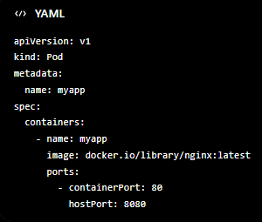
Cetvrto apply it later in kubernetes: kubectl apply -f myapp-kube.yaml or in podman: podman play kube myapp-kube.yaml
podman generate kube connects them because it takes a running Podman container or pod and converts it into a Kubernetes-style YAML file.
This helps move from local container management to Kubernetes orchestration, where the same application can be described declaratively using YAML.

Run a pod from a Kubernetes YAML with podman kube play, then tear it down with podman kube play -down.
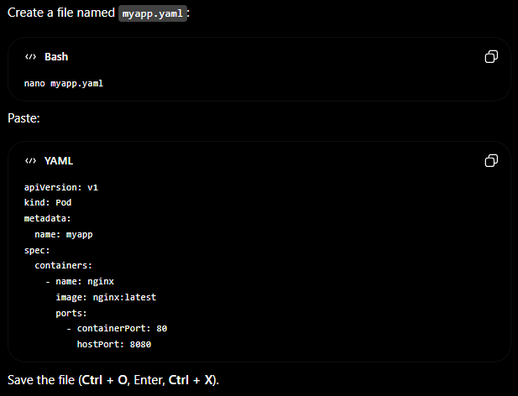
Run the pod: podman kube play myapp.yaml
Verify it is running: podman pod ps
Test app: curl http://localhost:8080
Tear down the pod: podman kube play --down myapp.yaml

Set per-service CPU/memory limits in a compose file and verify them with podman stats.
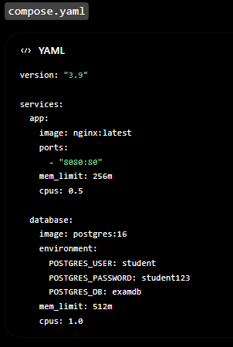
Podman compose up -d
Podman ps
Podman status
Inspect a pod with podman pod inspect and show which Linux namespaces the containers share (network, IPC) and which they don't (PID by default).
Prvo create a pod: podman pod create --name mypod
Drugo run two containers in the pod: podman run -d --pod mypod --name app nginx
podman run -d --pod mypod --name sidecar busybox sleep 3600
Trece inspect the pod: podman pod inspect mypod

Demonstrate name-based discovery failing when two containers are on different networks, then fix it by attaching them to a common network.
Prvo create two different networks:
podman network create net1
podman network create net2
Drugo run containers on different networks:
podman run -d --name app --network net1 nginx
podman run -d --name client --network net2 busybox sleep 3600
Trece try name-based discovery:
podman exec client ping -c 3 app
Cetvrto fix it
podman network create commonnet
podman network connect commonnet app
podman network connect commonnet client
Peto test again
podman exec client ping -c 3 app

Attach a single container to two networks (a frontend and a backend) and explain the segmentation benefit.
Prvo create two networks
podman network create frontend
podman network create backend
Drugo Run the container on frontend
podman run -d --name app --network frontend nginx
Trece attach it to the backend
podman network connect backend app
Cetvrto verify the networks
podman inspect app
Attaching a container to two networks provides network segmentation. The application container can communicate with both the frontend and backend networks, acting as a bridge between them. The frontend network is used for user-facing services, while the backend network is reserved for internal services such as databases. This improves security because backend services are not directly exposed to external clients.
Use podman compose logs and podman compose ps to observe and troubleshoot a multi-service stack.
Prvo start the stack (treba imati prvo compose.yaml sa app i database)
podman compose up -d
Drugo check the status of services
podman compose ps
Trece view logs
podman compose logs
Cetvrto view logs for a single service
podman compose logs database
Share configuration across two replicas of the same app via a shared named volume, and explain a risk of shared read-write storage.
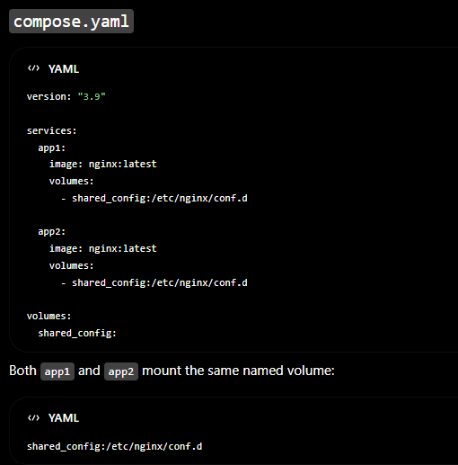
Start services: podman compose up -d
Verify the volume: podman volume ls
Demonstarate shared configuration: podman exec app1 sh -c "echo 'Hello from shared config' > /etc/nginx/conf.d/test.conf"
Check it from the other container: podman exec app2 cat /etc/nginx/conf.d/test.conf
A shared named volume allows multiple containers to access the same configuration files, ensuring all replicas use identical settings. However, if the volume is mounted with read-write access, multiple containers can modify the same files, which may lead to accidental overwrites, inconsistent configuration, or data corruption. Using read-only mounts for shared configuration helps reduce this risk.
Tear down a stack with podman compose down, then explain what happens to named volumes and how -volumes changes that.
Prvo start the stack podman compose up -d and podman compose ps
Drugo tear down the stack: podman compose down
Trece verify the volume still exists: podman volume ls
Cetvrto remove the stack and volumes: podman compose down –volumes
podman compose down stops and removes the containers and the Compose network, but keeps named volumes so that application data is preserved. This is useful for databases or other persistent storage.
Using podman compose down --volumes also deletes the named volumes. Any data stored in those volumes is permanently removed, so this option should be used only when the stored data is no longer needed.

